KBE Notes

Inhoud

UML overview 2

Assembly 2

Higher Level Primitive 2

Capability module 2

# UML overview

See UML class diagram below

## Assembly

Class that gathers sizing data for relevant lifting surfaces and then either creates an assembly of HLP wing trunks to create the surfaces.

1. WingAssembly
2. Tail can either be:
   1. Conventional/Cruciform/T-tail
   2. H-tail/C-tail
   3. V-tail

## Higher Level Primitive

Classes that generate geometry based on parameter inputs.

1. Fuselage
2. Engine
3. WingTrunk

## Capability module

Classes that compute relevant data

1. Area
2. Weight
3. Aerodynamic
   1. Lift Gradients
   2. Downwash gradients
   3. Aerodynamic center
   4. Mean Aerodynamic Chord
4. Tail sizing
5. Wing positioning
6. Rudder blanketing
7. Deep stall
8. Xfoil output
9. Catia output
10. PDF output
    1. Trimetric view (drawing)
    2. Pdf from xfoil with airfoil + CL-alpha plot + CL_max + alpha_stall
    3. All input values and computed
11. Q3D output

# Capability module description

## Aerodynamic module

The aerodynamic module calculates various aerodynamic properties of the created model:

* Lift Gradients
  + Wing CL_alpha_w
  + Fuselage-wing combination CL_alpha_wf
  + Horizontal tailplane CL_alpha_h
* Downwash gradients
* Aerodynamic center
* Mean Aerodynamic Chord

### Lift gradients

**For the wing:**

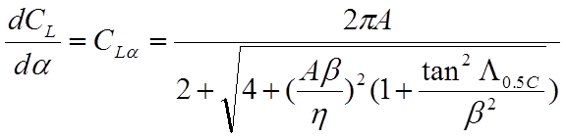





Note: units [1/Rad]

**For the Fuselage-wing combination:**

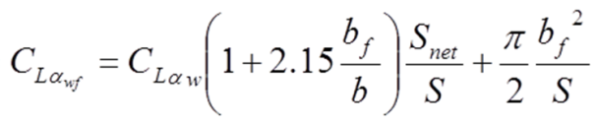

Note: bf and S_net according to picture below:

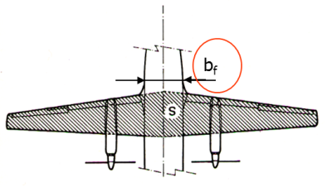

**For the horizontal tailplane:**

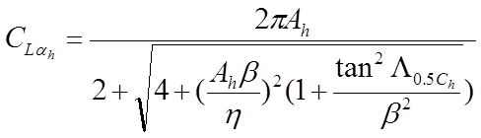



Note: Same formula as for the wing, however Mach number should take into account that speed is lower due to fuselage:

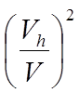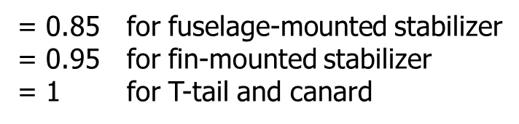

Note: in case of H-tail Ah can be increased by 1.5